A ROBUST BACKSTEPPING HIGH-ORDER SLIDING MODE CONTROL STRATEGY FOR GRID-CONNECTED DG UNITS WITH HARMONIC/INTERHARMONIC CURRENT COMPENSATION CAPABILITY
ABSTRACT
This paper presents a new nonlinear current control strategy based on backstepping control and high-order sliding mode differentiator in order to employ distributed generation (DG) unit interfacing converters to actively compensate harmonics/interharmonics of local loads. The converter-based DG unit is connected to a weak grid (with uncertain impedance) and local load (that can be parametrically uncertain and topologically unknown) through an LCL filter. The proposed strategy robustly regulates the inverter output currents and delivers pure sinusoidal, three-phase balanced currents to the grid. The new controller demonstrates the robust performance and robust stability of the DG unit system with respect to the filter parameters uncertainties, grid impedance, grid frequency, and grid voltage as well as the unknown load dynamics that include unbalanced loads and nonlinear loads with harmonic and interharmonic currents. We should remark that the local compensation of the loads with interharmonic current using a DG unit system is first proposed in this paper. When compared with the popular parallel proportional resonant control technique, the proposed controller offers smoother transient responses and a lower level of current distortion. The performance of the proposed control strategy is verified in MATLAB/SimPowerSystems toolbox.

BLOCK DIAGRAM FOR PROPOSED SYSTEM
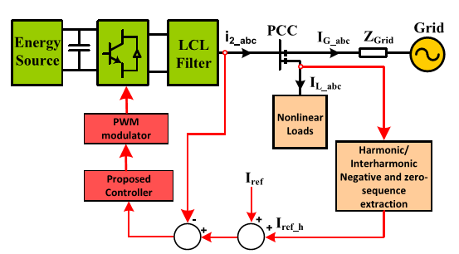
Fig. 1. Compensation scheme for current-controlled DG unit.
DESIGNG SOFTWARE AND TOOLS:
MAT LAB /SIMULATION Software and simu power systems tools are used. Mainly control system tools, power electronics and electrical elements tools are used.

